(HW2)

(HW3)

(HW5)

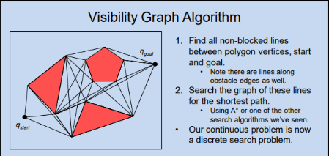

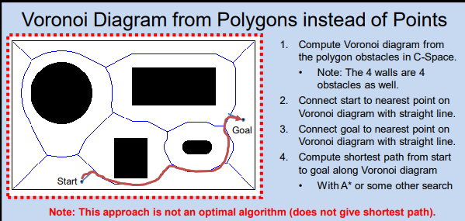

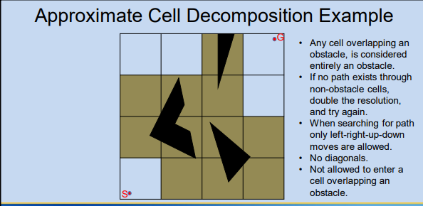

(HW6)1. For each node, indicate the initial availability lists if we were to do one pass of forward

checking (only) off of the two pre-colored nodes.

a. Initial availability = {G,B},b. Initial availability = {R,G,B},c. Initial availability = {R,G,B},d. Initial availability = {R,G,B},e. Initial availability = {G,B},f. Initial availability = {B},g. Initial availability = {B}

2. For each node, indicate the availability lists after running complete constraint

propagation, but without any search.

a. {G,B},b. {R,G,B},c. {R,G},d. {R,G,B},e. {G,B},f. {B},g. {B}

3.Most Constrained = {a,c,e}.

4.Node Selected = {a,c}.

5. Blue is the least constrained value for variable A.

6. By hand, run constraint satisfaction search, applying constraint propagation at each step,

a. G,b. B,c. R,d. G,e. B,f. B,g. B

